GCSE PE (9-1) - 5 a day revision questions 2022
Complete 5 practice exam questions a day to help you succeed. Use any highlighted gaps in your knowledge to focus your revision. Good luck!

We have extra revision tips available on YouTube and TikTok

1. A sprinter includes speed work in their training. Which one of these principles of training are they using? (1)

A Progressive overload
B Reversibility
C Specificity
D FITT

2. Figure 2 shows a representation of macronutrients and micronutrients in a balanced diet for a healthy adult. State the missing micronutrient labelled A. (1)
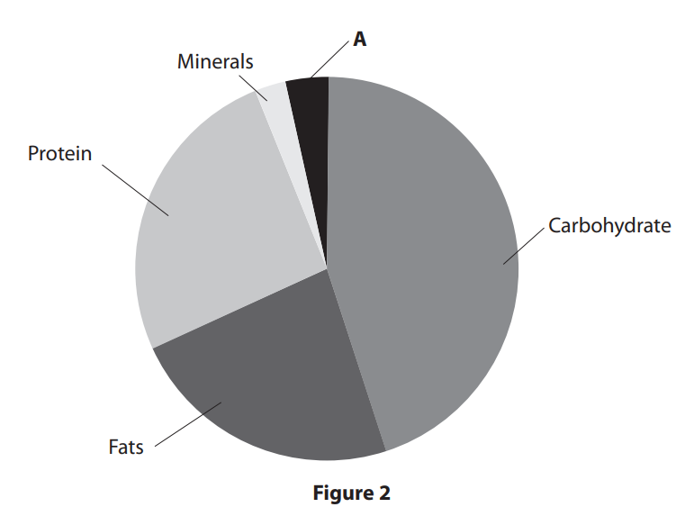
3. The bones of the skeleton protect the ......................................................................................... For example, in a football match if two players clash heads when trying to head the ball, the ..................................................... protects the .................................................................... (1)

4. Sex is one factor that can affect optimum weight. (a) State two other factors that can affect optimum
weight. (2)
Factor 1
Factor 2

5. The weight training class starts with a warm-up and ends with a cool down. Explain why Miss Convoy makes sure that the class stretches as part of the warm-up. (2)

Flash Revision Cards available for £17.99. Buy online or visit amazon.co.uk
https://www.peresourcesbank.co.uk/product/gcse-9-1-pe-revision-flash-cards-aqa/

Answers
1. C
2. Minerals
3. Vital organs/organs (1)
Cranium/skull (1)
Brain (1)
4. Height
Bone structure/density
Muscle (girth)
5. To increase elasticity/pliability/temperature of muscles (1) so they are less likely to become injured during the class (1)
• To increase the mobility at the joints (1) therefore increasing the range of movement possible (1)
• To increase the range of movement (1) improving technique during the class/reducing risk of injury (1)

